CCT
Use Case Model
April 2007

CCT
Use Case Model
Document Version 1.0

Sapient

Table of Contents
1 Actors 2
2 Issue Tracker Use Cases 3
2.1 Use Case Model diagram 3
2.2 Use Case Briefs 4

Actors
Type | Profile: Background and Skills
Project Manager | The Project Manager is responsible for setting up and managing the support infrastructure for the project. As such, the Project Manager has responsibility for setting up the environment, managing team member access, and approving final content to the system.
Team Member | The Project Team Member is a participant on the team. The team member will require access to the system to add and update the repository, issue tracking and document management functions. The project team member will need to manage their own personal profile to essentially have a ‘my Sapient CSD’ look and feel.
Application Administrator | The System Administrator is responsible for the overall set up of the system. The System Administrator is responsible for setting up new projects and users on the system. They also perform various system management functions such as archiving data, moving functions, implementing system upgrades, etc.
Issue Creator | The issue creator is the person the initiates the issue in the issue tracker module. They are the only person that can set an issue to the fixed state.

Issue Tracker Use Cases

Use Case Model diagram
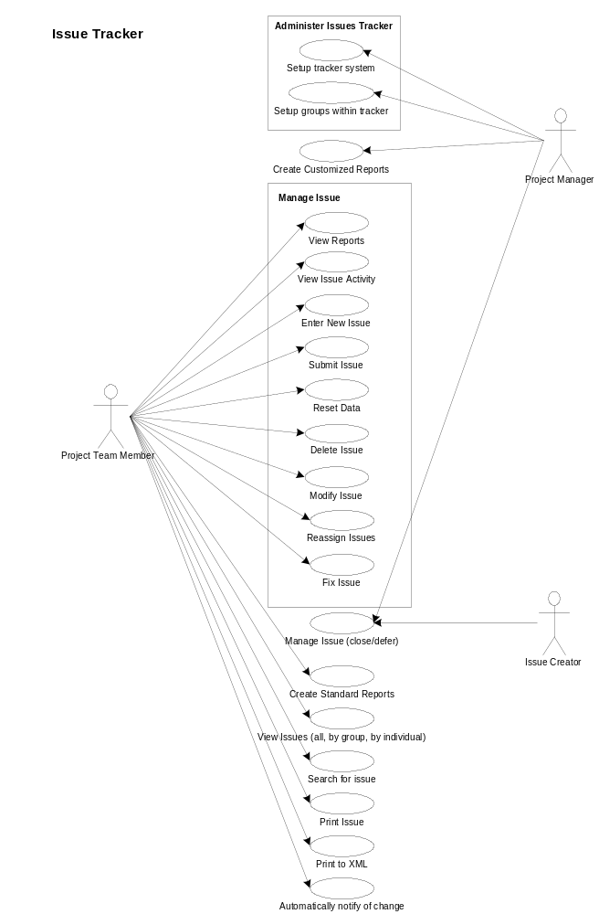

Use Case Briefs

Use Case | Actor | Brief
Setup tracker system | Project Manager | Provides the project manager the ability to set up and customize the issue tracker. In this area, there are standard fields required by Sapient, but additional fields that the PM can select based on their project. Also, here for certain fields the PM can modify or select which drop down values are appropriate for their system.
Setup groups within the tracker | Project Manager | This provides the ability to setup predefined groups within the project that allow groups to be included or excluded from viewing an issue.
Create customized reports | Project Manager | Provides the ability for the Project Manager to setup customized reports based on the unique requirements of the project.
View reports | Team Member | Provides the ability for the user to view standard reports as well as those reports that have been customized for the project specific requirements.
View issue activity | Team Member | Enables the team member to view any changes that have been made to the issue.
Enter new issue | Team Member | Allows the user to enter a new issue without submitting it to the issue tracking system.
Submit new issue | Team Member | Provides the ability for a team member to create and add a new issue to the issue tracker. In this use case, the team member will need the ability to assign any dependencies between any existing issues, set a target milestone. The use case will enforce the collection of critical information.
Reset data | Team Member | Allows the user to return all fields to their previously submitted values.
Delete issue | Project manager | Provides the ability for the Project Manager to delete an issue from the issue list. For example if there is a duplicate issue raised, this allows the PM to clean up the issues list. It is a hard delete from the issues database.
Modify issue | Team Member | Provides the ability for user to update any information around the issue (other than the tracking information). There may be security constraints around specific fields that prevent different roles from changing a field/data.
Reassign issues | Team Member | Provides the ability for the team member to reassign an issue to another person on the team for resolution.
Designate issue as fixed | Team Member | The person who fixes the issue, designates it as fixed. Then workflow will notify that the creator that the issue is resolved for them to verify. Once verified they can designate the issue as fixed.
Manage issue | Project Manager/Issue Creator | The Project Manager is the person who is allowed to designate the issue is open, closed, fixed or deferred. Only the issue creator is allowed to designate the issue as fixed.
View all Issues (all, by group, by individual) | Team Member, All Sapient | View a list of all outstanding issues. Be able to quickly filter the issues by an individual or by group.
Search for an issue | Team Member | This provides a robust search functionality for the user to search and or group issues. Search functionality must provide the ability to view the results in groups (i.e., by within a date range, for selected issue owner or owners, by issue type, etc.)
Print issue | Team Member | Allows the user to print the issue.
Format issue as XML | Team Member | Displays the issue as XML.
Automatically notify of change to an issue | Team Member | The system will automatically notify selected users that an action has changed within the issue. This will send an email to the user. Based on the individual preference (set in the admin section) the user will be able to opt in or out of the notification, and determine what specific actions warrant notification.

